***What is a virtual visit?***

*A virtual visit is a secure video appointment with your provider that can be done on a web browser or via your smartphone or tablet. This allows patients to conduct a traditional office visit with their provider electronically through their MyChart app or MyChart Account without leaving home or work.*

**What are the technical requirements for a virtual visit?**

* You must have a mobile phone/tablet with the Apple iOS or Android operating system or a PC/Laptop with web camera & sound capabilities.
* For smart devices you must have the **MyChart** app installed and select the appropriate organization.
  + You can find the MyChart app in the [Apple App Store](https://apps.apple.com/us/app/mychart/id382952264) (iPhone or iPad) or in the

[Google Play Store](https://play.google.com/store/apps/details?id=epic.mychart.android) (Android).

* **For PC/Laptops you will need to access your MyChart account via web browser. You must use either Google Chrome, Microsoft Edge, or Safari.



**Here’s how to do it:**

1. If using the Mychart app search for the **MyChart** app from the Apple App Store for an iPhone or iPad or from the Google Play Store for an Android smartphone or tablet and download it to your device.
   * After downloading the MyChart Application, you must identify and add your healthcare organization by typing your organization in the search bar at the top. Select the organization by clicking on the appropriate logo. Click the green **Continue to Login** button and login using the same credentials you used to set up your MyChart account.

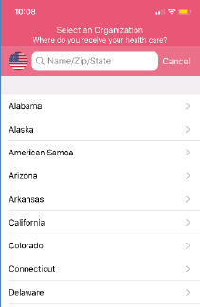 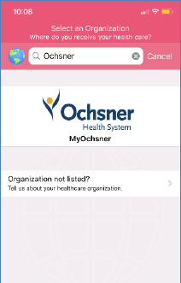 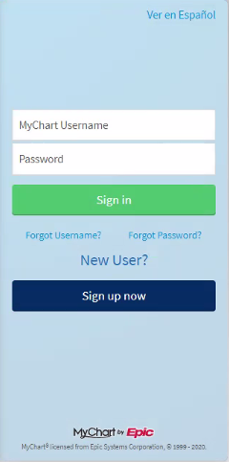

1. Once your video visit is scheduled you will need to complete ePre-Check in your MyChart account before your visit. ePre-Check is available 7 days prior to your scheduled appointment.
   * During ePre-Check you will verify your insurance, demographics, and sign the Telehealth consent form.

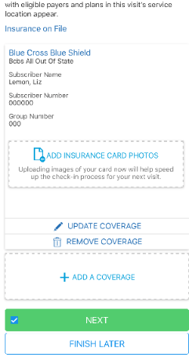 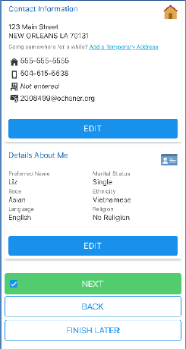 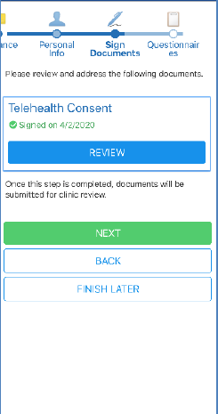

1. After you successfully allowed access to your camera and microphone and it is time for your appointment, follow the steps below to complete your visit.
   * Select **Visits** from the home screen of the MyChart account and find today’s Virtual Visit, listed under Upcoming Visits.
     + Click on the **Details** button of your Virtual Visit.

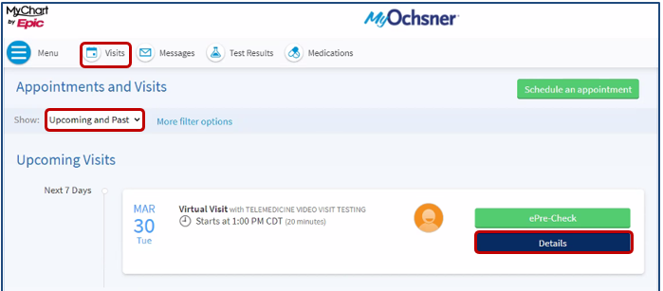

1. From within ‘Details’ you can select **Test Hardware** to make sure your microphone and camera are functioning properly prior to your joining your Virtual Visit appointment.

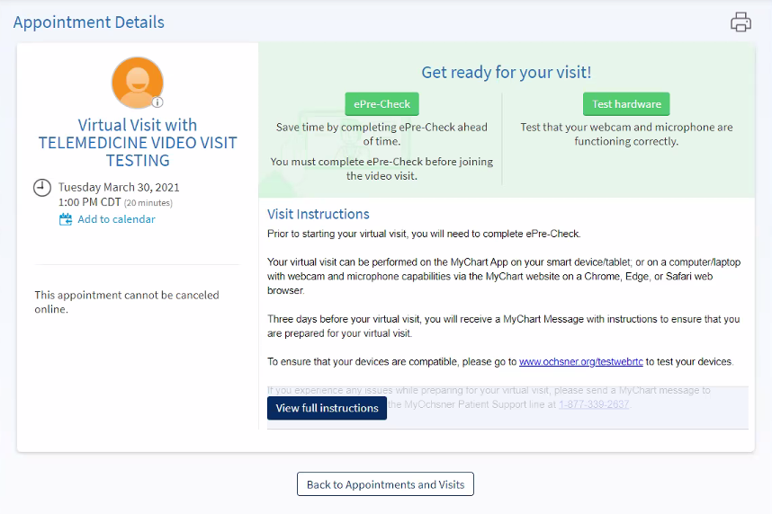

1. When you are ready to enter your virtual visit click the **Begin Video Visit** button.

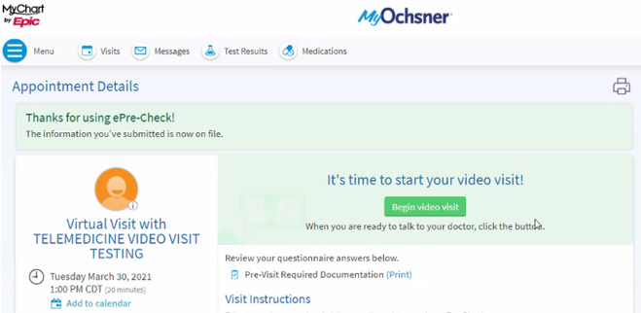

1. You will be redirected to the Virtual Visit website via Chrome, Microsoft Edge or Safari.
   * You will need to allow access to your camera and microphone before your virtual visit begins.
     + Click on the virtual visit appointment to view the appointment details. Select **OK** or **Allow** when asked for permission to your camera and microphone.

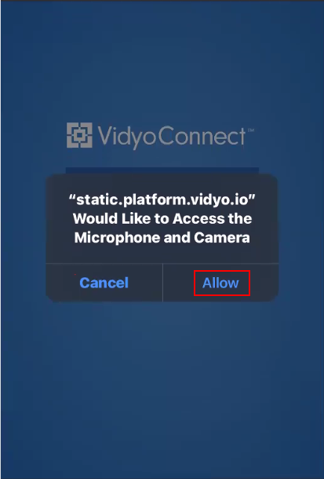

* Make sure to select the **Agree to Vidyo Terms & Conditions** checkbox then select **Join** once you are ready to begin your appointment.
  + **Note**: it may take a few moments to load once you join the visit.

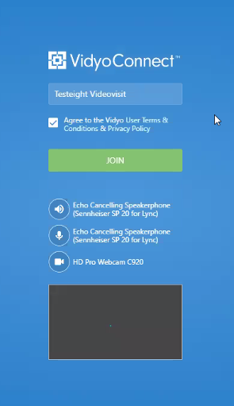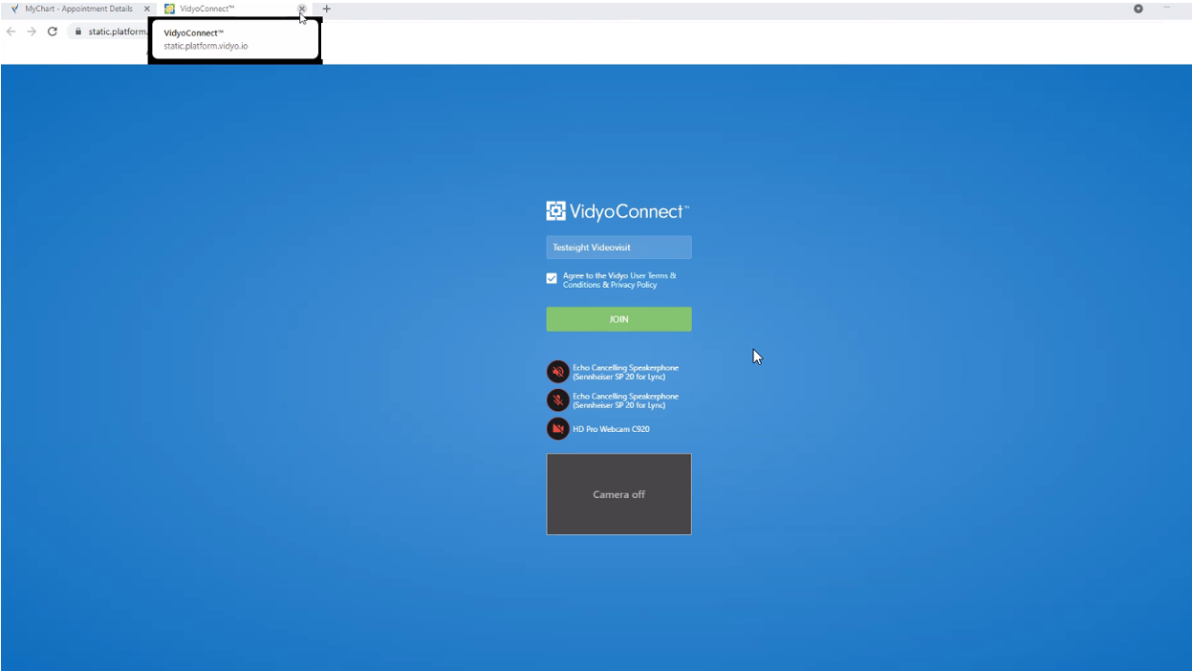

1. Once selected you will enter a virtual visit waiting room until your provider arrives. Please stay on this screen while you wait for you provider to join (the provider will automatically be notified that you are in the waiting room).



* **To learn more about virtual visits go to:**
  + MyOchsner | Ochsner Health ( <https://www.ochsner.org/my-ochsner> )
* As of April 2021, the Minimum Version Requirements are noted for reference. Using a supported platform or browser will help ensure the success of a virtual visit. (Please note that these are subject to change in the future.)

 

